**S-Board**

**(Student-Board)**

**Third Increment of Project**

**PG-8**

Submitted

by

Muppalla Jaya Sai Krishna Miryala Naveen Kumar

Class ID: 26 Class ID: 24

Nalluri Krishna Chaitanya Pavuluri Sai Rahul

Class ID: 27 Class ID: 31

**MOTIVATION:**

The project aims at regulating the various In-class activities of the students through our online web service by providing some discussion forms. The students can also be aware of the assignment evaluation and class participation reports through our service. Also the professor can also notify the students by posting important announcements and the student involvement in various the course activities.

**Use Case Diagram:**

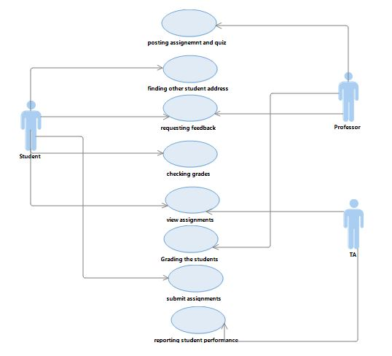

**Class Diagram:**

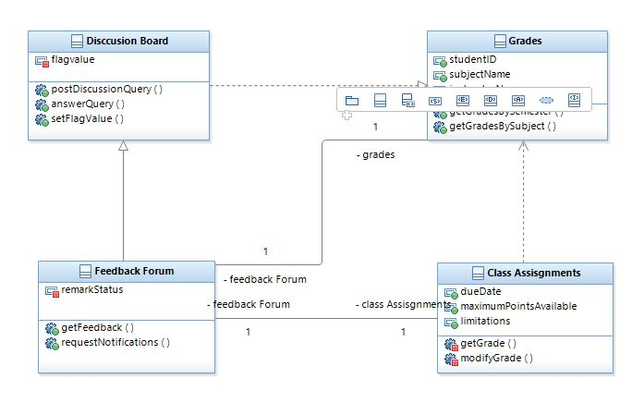

Activity Diagram:

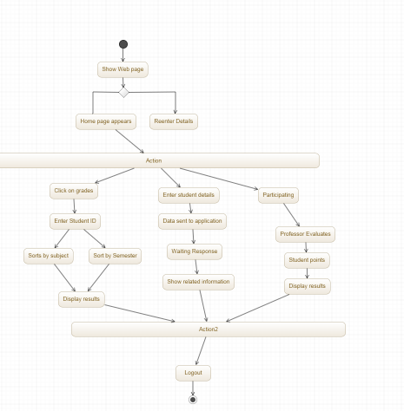

**Software Specifications:**

* Tools: Android Development Kit, Microsoft Visual Studio
* Operating System: Android, Windows
* Development Operating System: Windows 8
* Programming Language: C#,ASP.NET
* Databases: MySQL
* Platform: Liberty Java in BlueMix

**GitHub Link:** <https://github.com/jmmvd/ase-project/tree/master/increment%203/aseq>

**Implementation:**

**Home Screen of our System**

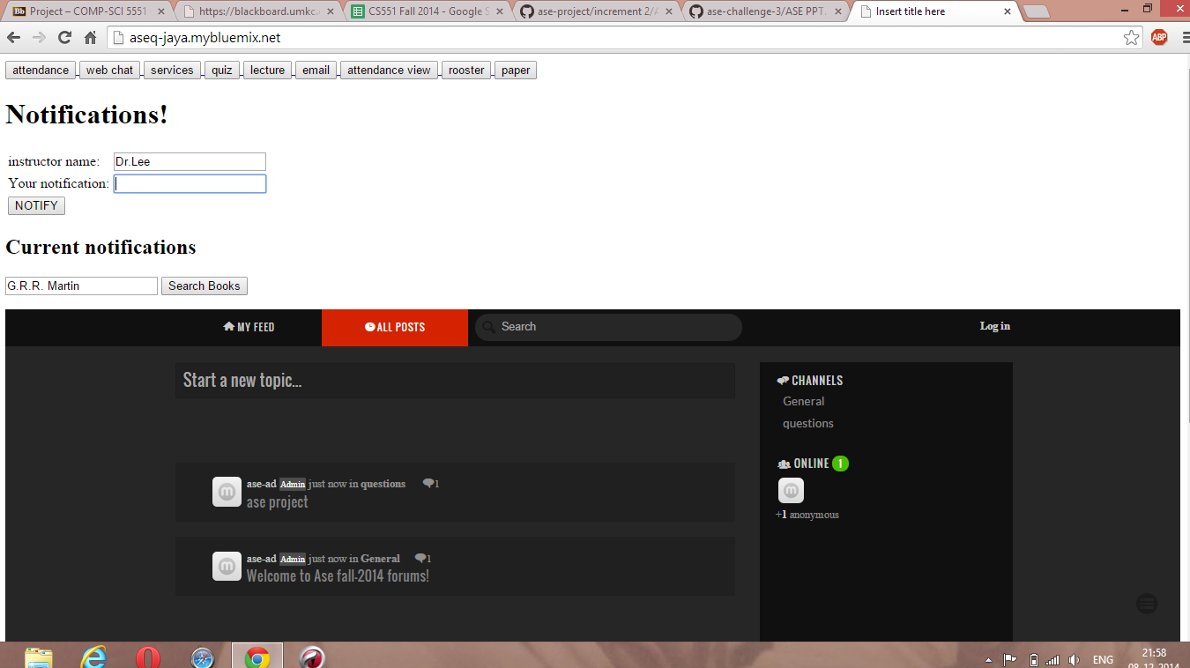

**Marking Attendance of students:**

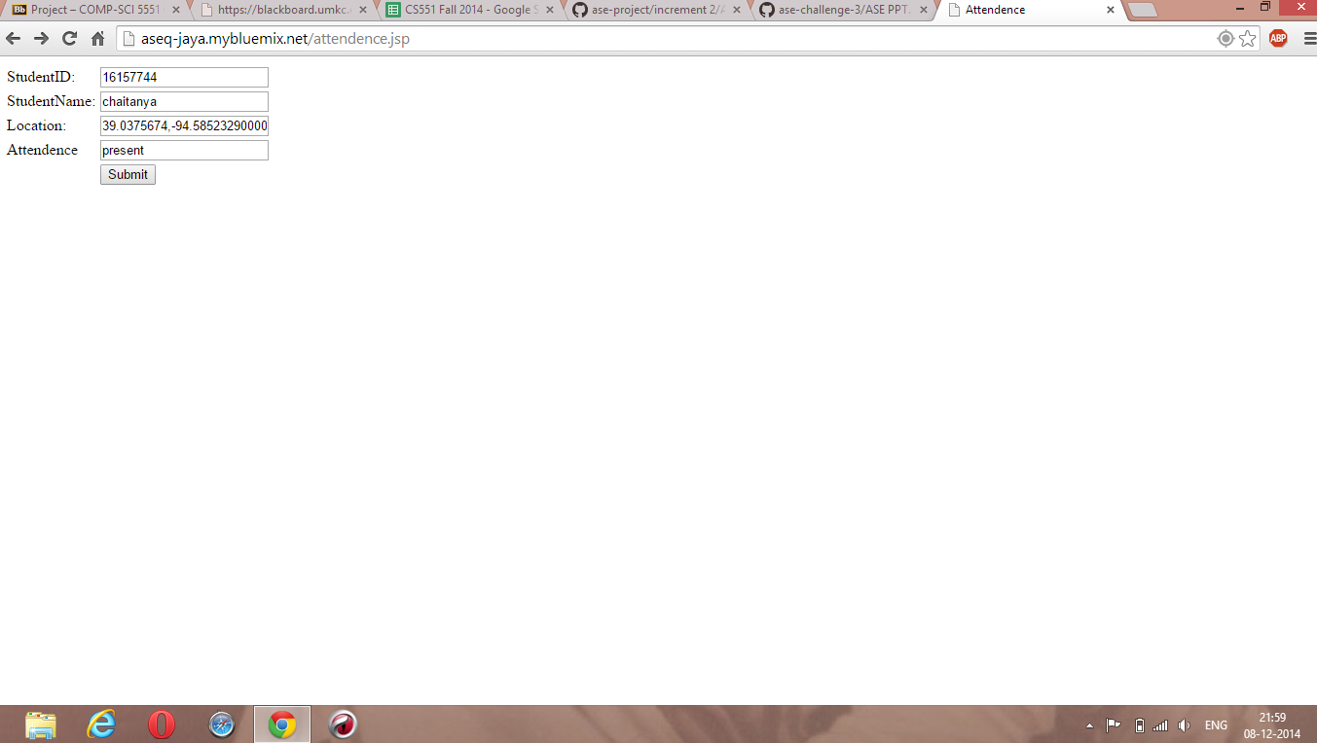

**Getting the data from the MySql Database:**

We can pull the details of the students from the MySql Database including the location details as well.

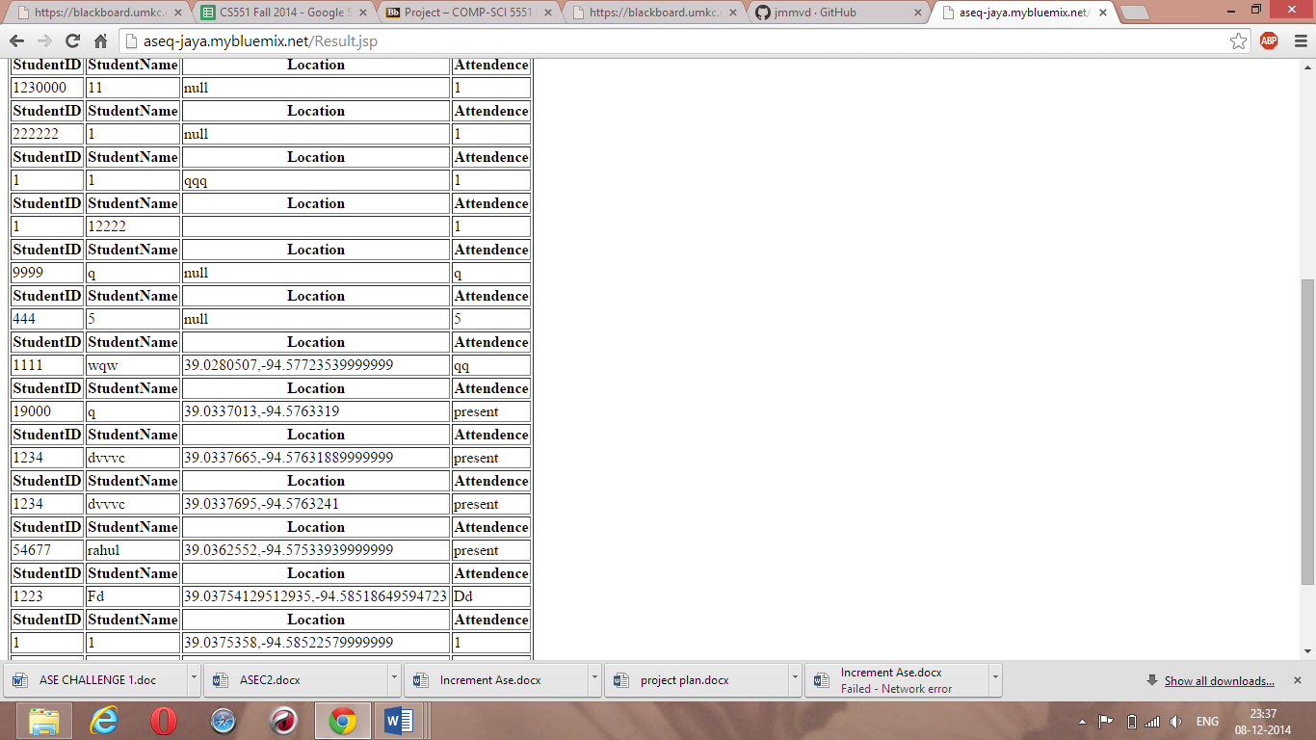

**Getting directions between two places:**

We had Implemented the Google Maps service in our system to get directions.

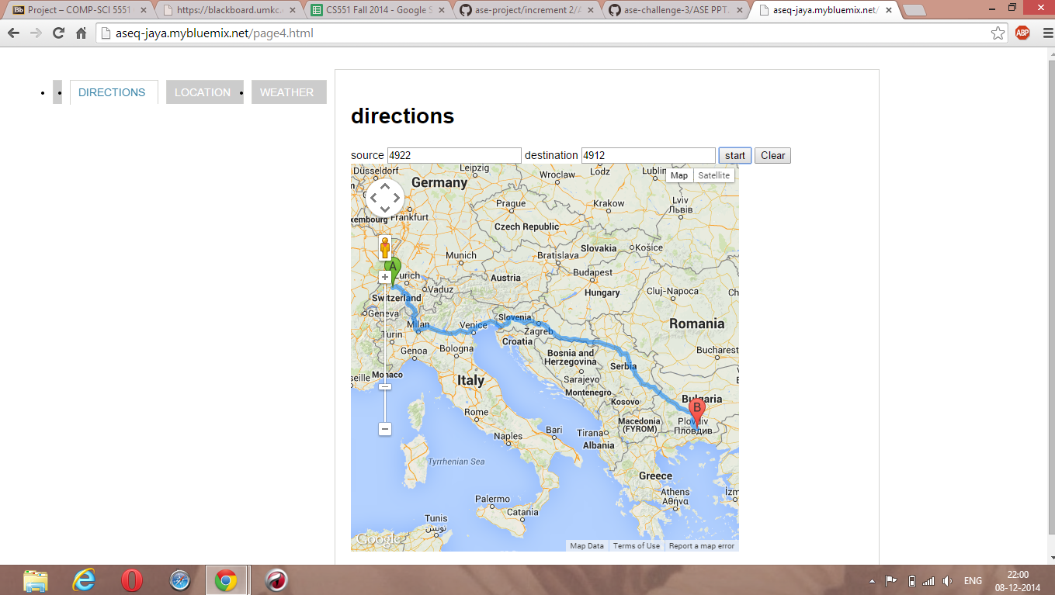

**Checking the location of the student:**

The student can only take the online quizzes if he is in the class and so we check whether the student is actually present in the class or not.

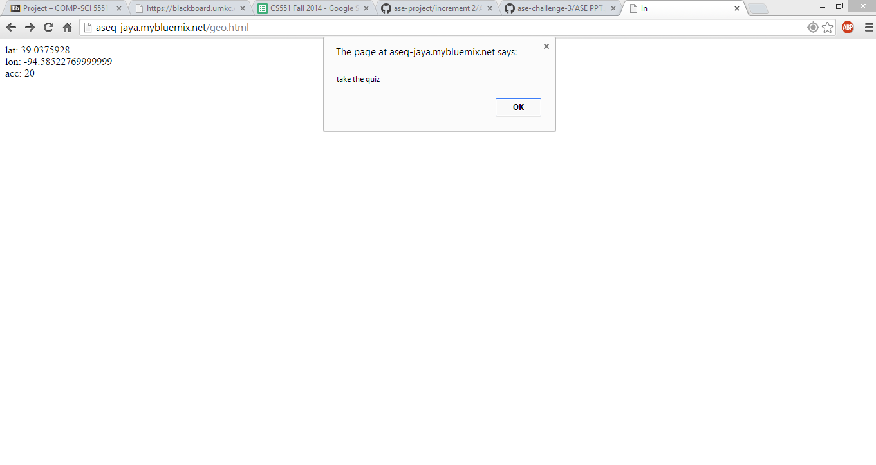

**Answering the Quizzes:**

We used the ‘proprofs’ web service to create the quizzes and the students can be able to answer them accordingly.

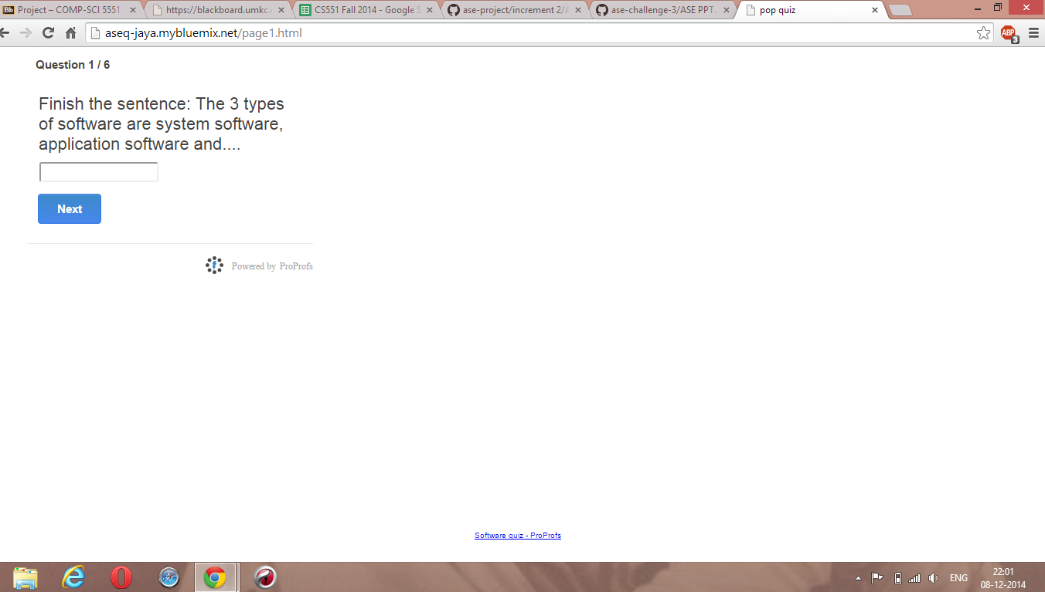

**Implementing the Rooster Service:**

Using this service any student can search and check the details of another students and get their residential address as well.

